u|Lg ;f];fO6L klAns :s'n
/=g=kf=–&, ;f}/fxf, lrtjg
t];|f] q}dfl;s kl/Iff
laifoM g]kfnL] k"0ff{ª\sM %)
sIffM o'= s]= hL= pQL0ff{+sM !*

gfd====================================================== /f]n g+================================ ;]S;g======================
k|fKtfË
ko{j]Ifs
k/LIfs

k|Zg g+= ! k|Zg g+= ! …dfqf nufP/ n]Vg'xf];\ . -#_
s ± f Ö 5 ± ] Ö
v ± ' Ö h ± " Ö
r ± l Ö u ± F Ö
k|Zg g+= # rGb|ljGb' - F _ nfu]sf zAbx¿ n]Vg'xf];\ . -#_

k|Zg g+= $ cf]sf/ -f]_ dfqf nfu]sf zAbx¿ n]Vg'xf];\ . -#_

k|Zg g+= $ k|Zgsf] pQ/ lbg'xf];\ . -#_
s_ tkfO{+sf] gfd s] xf] <
d]/f] gfd xf] .
v_ tkfO{ slt aif{sf] x'g'eof] <
d aif{sf] ePF .
u_ tkfO{+slt sIfdf k9\g'x'G5 <
d sIff k9\5' .
k|Zg g+= % ;'?sf] cIf/df lz/ljGb' nufpg'xf];\ . -%_
ruf buf /u x; cu'/
k|Zg g+= ^ j0f{ hf]8]/ zAb agfpg'xf];\ . -%_
d" uf{
j vf{
b' iff{
s' lt{
r ;L{
k|Zg g+= & lbOPsf] ;d"xjf6 nofTds gePsf zAbx?nfO{ s|; lrGx nufpg'xf];\ . -%_
hbf} bf}/f
ebf}
rf}w sf}jf
6f}jf
sf};L df}/L
cf};L

gf}nf] sf}8L
kf}8L
nf}sf gf}sf
sf}jf

k|Zg g+= * zAb hf]8]/ jfSo agfpg'xf];\ . -%_
lsg nufpm /fv
af]s agfpm
sf]6 emf]nf rf]nf] uf]nf] 6f]s/L

k|Zg g+= ( afx|v/L k"/f ug'{xf];\ . -^_
pbfx/0fM–s sf ls sL s' s" s] s} sf] sf} s+ sM
r

k|Zg g+= !) v'6\6f sf6]sf zAbdf dfq uf]nf] 3]/f nufpg'xf];\ . -^_
k|yd wf]s|f] cf]7
s]/fp h'd|f
k|;fb r+uf u|x
r}t af]s|f

k|Zg g+= !! lrqx]/L gfd n]Vg'xf];\ . -^_
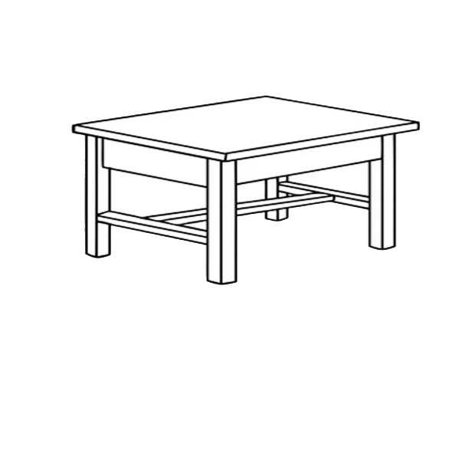 | 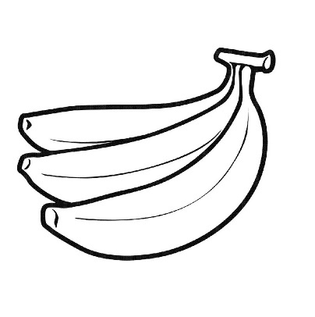 | 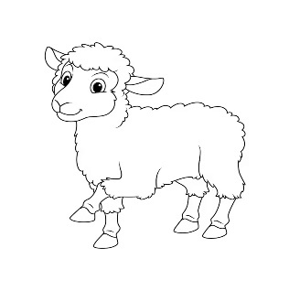
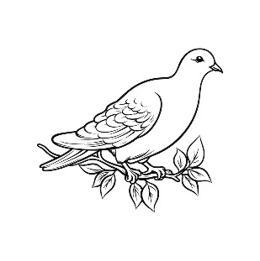 | 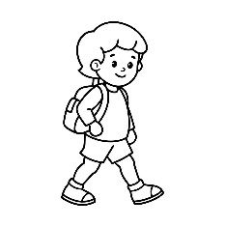 | 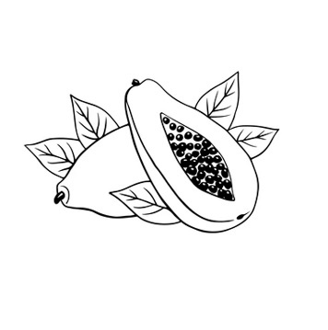
;dfKt

Green Society Public School
Ratnanagar-7, Sauraha, Chitwan
Third Term-2082

Subject: Social/Science Full Marks: 50
Class: UKG Pass Marks: 18

Name:________________________Roll No:_______ Sec:_______
____________ _________
OBT. MARKS
INVIGILATOR EXAMINER

- Write the name of the flower. (3)

- Name of sports. (3)

- Write the name of vegetable. (3)

- write the name of weather. (3)

- Write the name of product which we get from animal. (4)
Hen =
Cow =
Sheep =
Goat =

- Name of the given picture. (4)
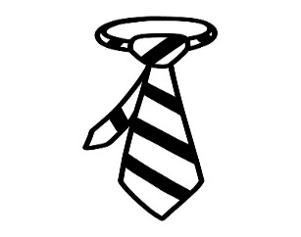 | 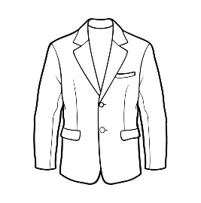 | 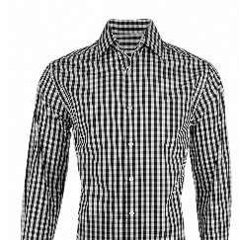 | 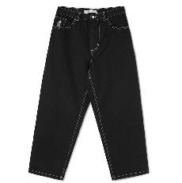

- Write 'good' and 'bad' . (5)
- Helping Friend
- Fighting with friends.
- Cutting Nails.
- Playing on road.
- Brushing teeth.
- Fill in the Blanks. (5)
- Our national animal is ………………..(cow, Dog).
- Our national Bird is……………………………………( Lophophorus, Parrot).
- Our National flower is…………………………………(Rhododendron, Lily)
- Our National colour is ……………………………..(Crimson, yellow)
- Our national weapon is ……………………………(Khukuri, Knife)
- Match the following. (animals with their baby) (6)
Dog kitten
cat puppy
sheep piglet
Goat Cub
Tiger kid

- Write healthy and unhealthy food. (6)
Rice Noodles egg meat drinks sugar

Healthy | Unhealthy

- Write the name of parts of plant. (7)
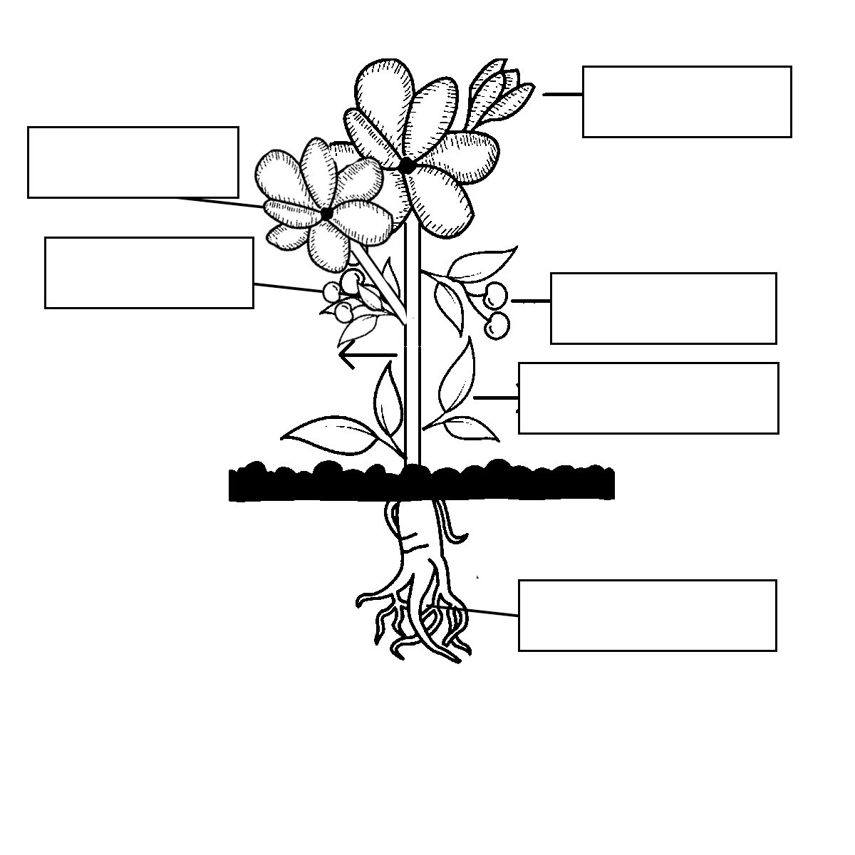

The End

Green Society Public School
Ratnanagar-7, Sauraha, Chitwan
Third Term
Subject: Math's Full Marks: 50
Class: UKG Pass Marks: 18

Name:________________________Roll No:_______ Sec:_______
____________ _________
OBT. MARKS
INVIGILATOR EXAMINER

- What comes before. (3)
……..…. 27 …………. 14 ………….. 16
………… 38 …………. 20 ………….. 11
- Subtraction.(-)
9 4 7
-3 -2 -7

- addition.(+) (4)
T O T O
4 3 5 2
+2 6 +4 7

- Write down Devanagari numbers. (5)

- Write the numbers name. (5)

              - 60=……………………….
              - 72=………..….……..…..
              - 64=………….…..……….
              - 75=………………………
              - 80=………………….……
- Write odd and even numbers. (5)
eg. | 12 | Even
 | 17
 | 20
 | 14
 | 11
 | 15
- Compare the numbers and put sign ‘<’, ‘>’ and ‘=’. (5)

26 | 20
30 | 28
18 | 21
24 | 24

27 | 21

- Write the ordinal numbers. (5)

7=…………….
3=……………
4=……………
6=……………
9=……………

- Match the following. (5)
4 times 2 8x3
3 times 5 6x4
8 times 3 5x3
6 times 4 4x2
5 times 3 3x5

- Write the name of shape. (5)

- Colour the half part of the given picture. (5)






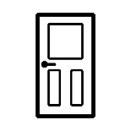
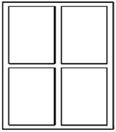

The End

Green Society Public School
Ratnanagar-7, Sauraha, Chitwan
Third Term
Subject: English Full Marks: 50
Class: UKG Pass Marks: 18

Name:________________________Roll No:_______ Sec:_______
____________ _________
OBT. MARKS
INVIGILATOR EXAMINER

- See the picture and tick the correct sentence. (3)
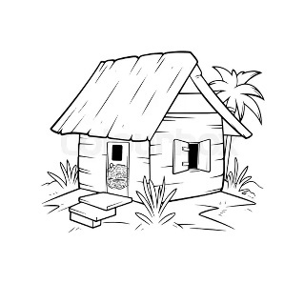 | A nut is in the hut.  A nut is on the hut.
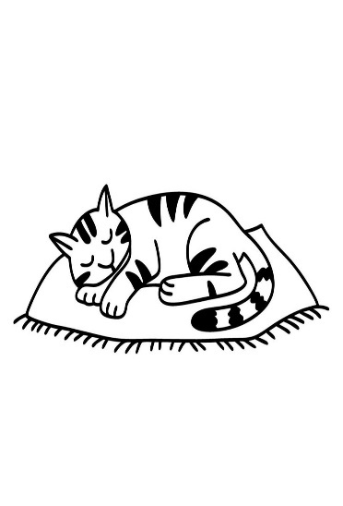 | A cat is on the mat.  A mat is in the cat.
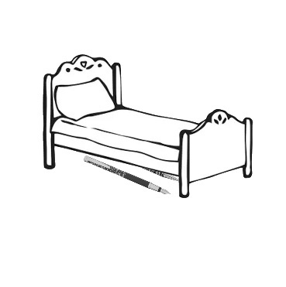 | A pen is under the bed.  A pen is in the bed.

- Change singular into plural (5)

baby =
cat =
book =
potato =
copy =

- Write opposite word. (5)

Up =
In =
Good =
Girl =
Happy =

- Add 'ing' . (5)
Drive=
Run=
Sing=
Write=
Go=
- Put 'A' or 'an' before the word. (5)
……….bench …………..iron
……….pen …………..fan
……….ox
- Mach the sentences with the correct picture. (5)
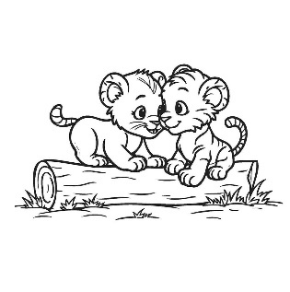 |  | Those are gems
 |  | Those are cubs.
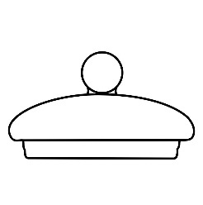 |  | That is mop.
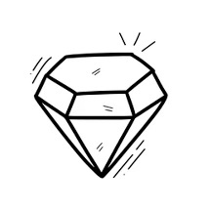 |  | Those are lids.
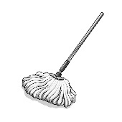 |  | That is tab.

- Fill in the blanks with 'is' 'am', 'are' (5)
- I…………….a student.
- She …………… a horse
- They ………….. farmers.
- We…………… friends.
- It ………….. a dog.

- Answer the question in 'Yes it is', or 'No it is not.' (5)
- Is that a hat?
………………………………………………..
- Is this a bug?
…………………………………………………
- Is this a man?
…………………………………………………
- Is this a book?
…………………………………………………
- is this a kid?
………………………………………………….
- Make sentences using He/She/It. (6)
walking | sleeping | eating | jumping | playing | writing

- Complete the paragraph. (6)
My name is……………………………………………….. I am ……..years old. I am a ………………(girl/boy). I study in ………………..My favorite colour is ……………………… I like to eat …………….

Green Society Public School
Ratnanagar-7, Sauraha, Chitwan
Third Term
Subject: Project work Full Marks: 50
Class: UKG Pass Marks: 18

Name:________________________Roll No:_______ Sec:_______
____________ _________
OBT. MARKS
INVIGILATOR EXAMINER

- Tick (√) for good behaviour and cross (x) for wrong ehaviour (4)
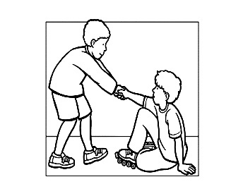
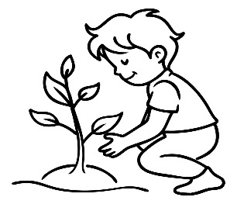

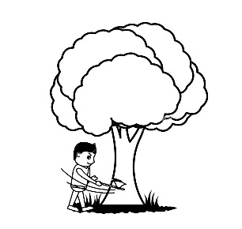
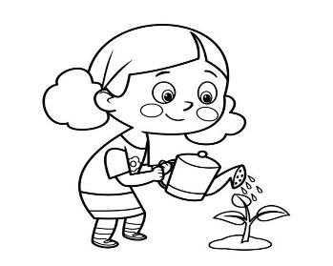

- Complete the picture by drawing other half part. (4)
 | 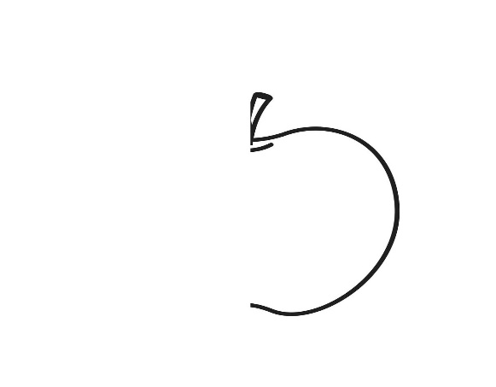
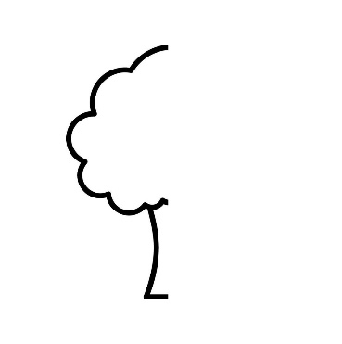 | 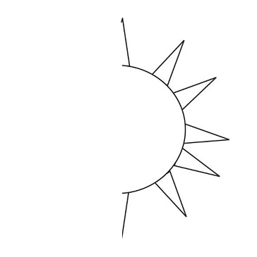

- Match the following with their name. (6)
Play ground | 
library | 
classroom | 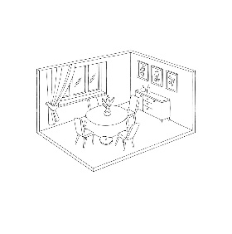
dining hall | 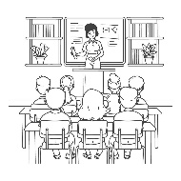
office | 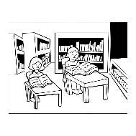
reception | 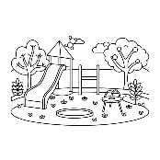
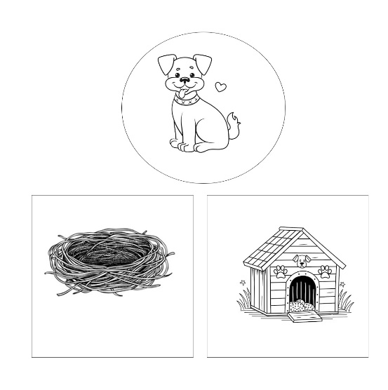
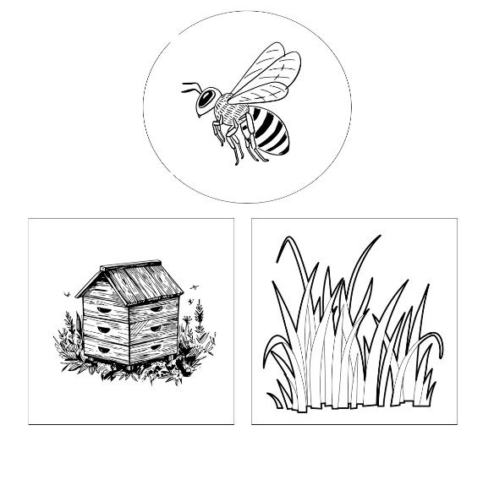
- Look at birds and insects and colour their correct homes.(6)

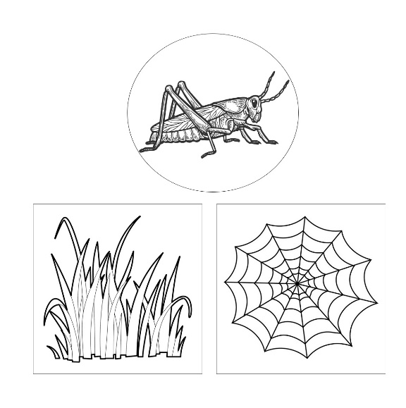
- Look at the picture and write 'Whole', 'Half', 'quarter' (6)
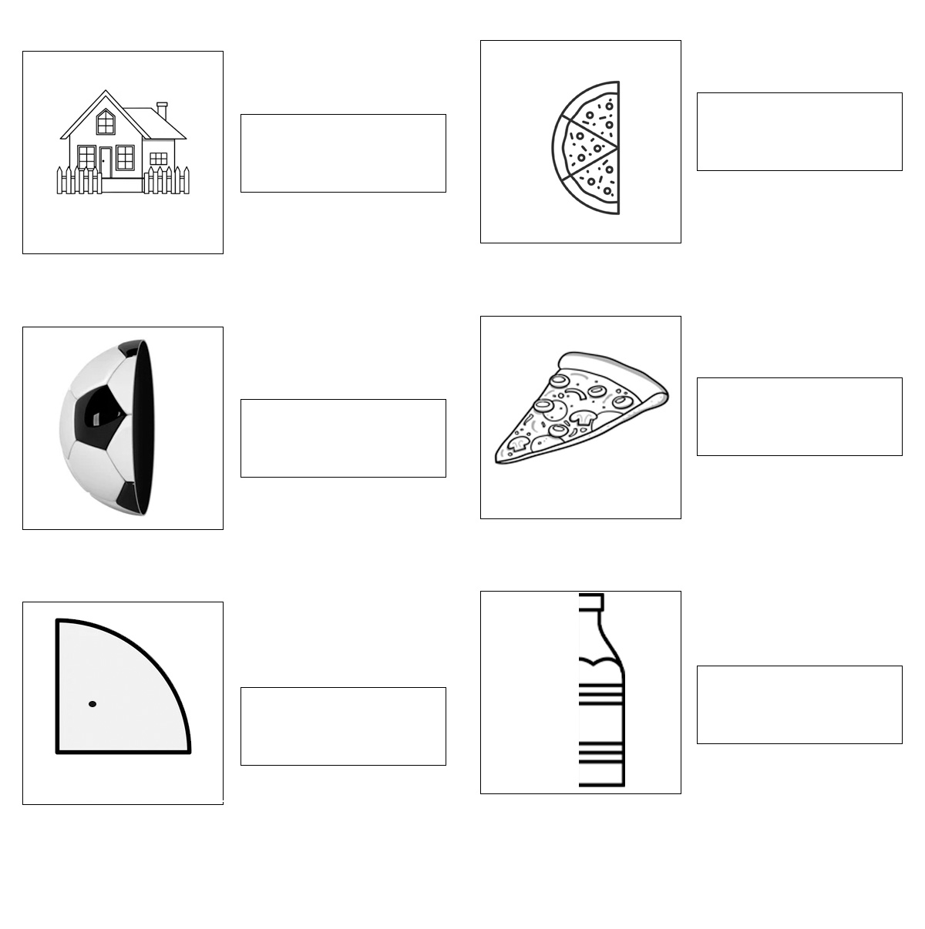
- Colour the traffic light and write about it with the help of key words. (7)
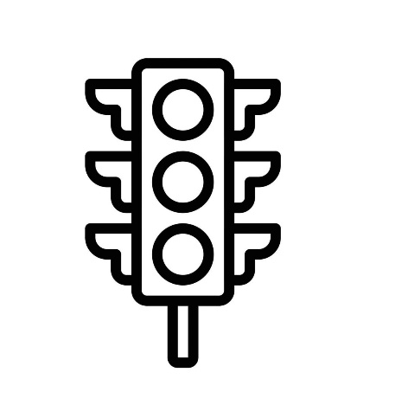 | Red light says ………………  Yellow light says……………  green light says……………..

- Draw the picture of best vehicle. (7)

- Colour the picture. (10)
